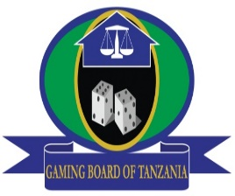
THE UNITED REPUBLIC OF TANZANIA
MINISTRY OF FINANCE AND PLANNING
GAMING BOARD OF TANZANIA

PUBLIC NOTICE
SUSPENSION ON ISSUANCE OF NEW
SLOT MACHINE/ROUTE OPERATION LICENCES
The Gaming Board of Tanzania (GBT) would like to inform the general public that, owing to the growing regulatory challenges, it has temporarily halted issuance of Slot Machines / Route Operation licences to the new applicants of the respective operation. The halt is intended to accord the GBT with an opportunity to complete setting up the Electronic Monitoring System which is intended to manage slot machines operations.
Meanwhile, the GBT will use this window to address the issues of illegal slot machines operations which has adversely affected the image of gaming industry. Resumption of licences issuance for this operation will depend on successful implementation of the stated measures.
For any inquiries pertaining to the regulation of gaming activities, kindly contact us through the address provided below.

Issued by
The Director General
Gaming Board of Tanzania
PSSSF Twin Towers, Wing A, 27th Floor, Mission Str./Sokoine Drive
P. O. Box 1717, Dar Es Salaam
Telephone: +255 22 221 4500; Facsimile: +255 22 212 4705
E-mail: info@gamingboard.go.tz; Website: www.gamingboard.go.tz

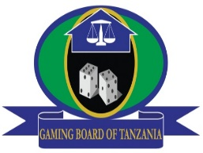
JAMHURI YA MUUNGANO WA TANZANIA
WIZARA YA FEDHA NA MIPANGO
BODI YA MICHEZO YA KUBAHATISHA TANZANIA

TAARIFA KWA UMMA
KUSITISHA UTOAJI WA LESENI MPYA ZA MASHINE ZA SLOTI
Bodi ya Michezo ya Kubahatisha Tanzania (GBT) inapenda kuufahamisha umma kuwa, imesitisha utoaji wa leseni za kuendesha biashara ya mashine za sloti (Slot Mashine/ Route Operation Licence) kutokana na kuongezeka kwa changamoto katika udhibiti wake. Hatua hiyo inalenga kuipa GBT fursa ya kukamilisha matengenezo ya mfumo wa udhibiti wa mashine za sloti nchini.
Katika kipindi hicho, GBT itaendelea kukabiliana na uendeshaji haramu wa biashara ya mashine za sloti ambayo imekuwa ikiharibu taswira ya tasnia ya michezo ya kubahatisha nchini. Zoezi la utoaji leseni litarejea mara baada ya kukamilika kwa mifumo ya udhibiti.
Kwa maelezo au maswali yoyote kuhusiana na usimamizi wa uendeshaji wa michezo ya kubahatisha nchini, tafadhali wasiliana nasi kupitia anuani hapo chini.
Imetolewa na;
Mkurugenzi Mkuu
Bodi ya Michezo ya Kubahatisha Tanzania
Mtaa wa Mission/Sokoine Drive,
Ghorofa ya 27, PSSSF Twin Towers, Wing ‘A’
S. L. P. 1717 Dar Es Salaam, Simu: +255 22 221 4500/0800 1100 51
Barua pepe: info@gamingboard.go.tz Tovuti: www.gamingboard.go.tz

